WPD6 10.3 – 12.50 GHz,2 rings

Table 1. Trace width and length for WPD6
Z0(90 degree) | W(mil) | L(mil)
59.49 | 30.87 | 1.5527e+02
84.05 | 14.39 | 1.5899e+02
50 | 42 | **

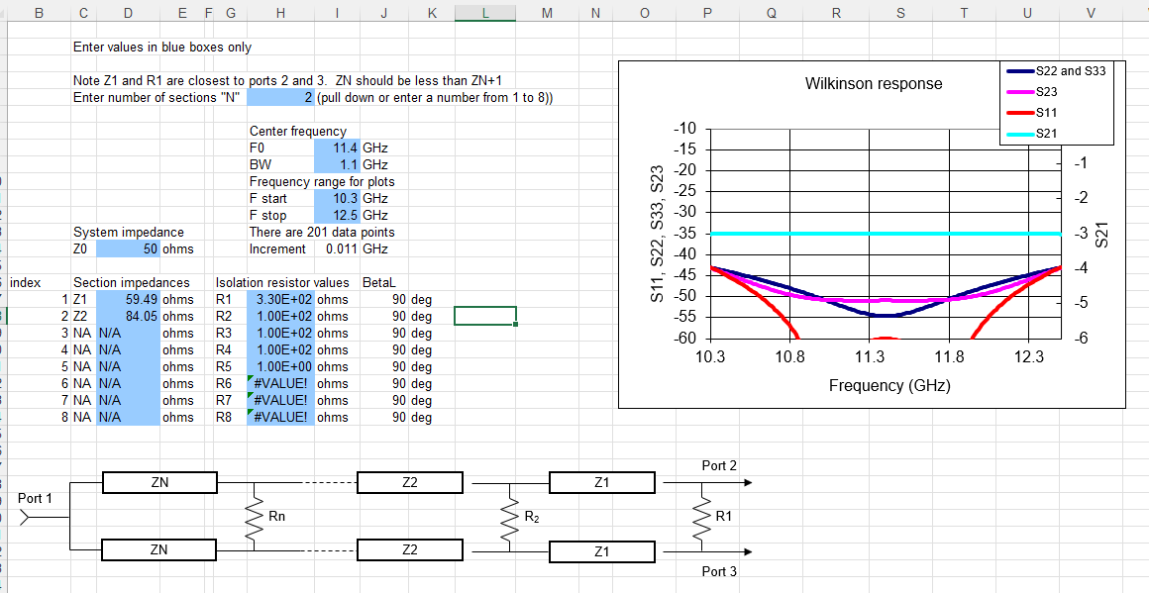
Figure 1. WPD6 parameters
